FOR IMMEDIATE RELEASE

Contact:
Emi Battaglia
Director of Marketing & Publicity
emi@reganarts.com
646-448-6616

JUDITH REGAN RETURNS TO FICTION: ANNOUNCES NEW NOVEL BY VOGUE EDITOR TAYLOR ANTRIM

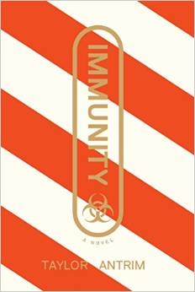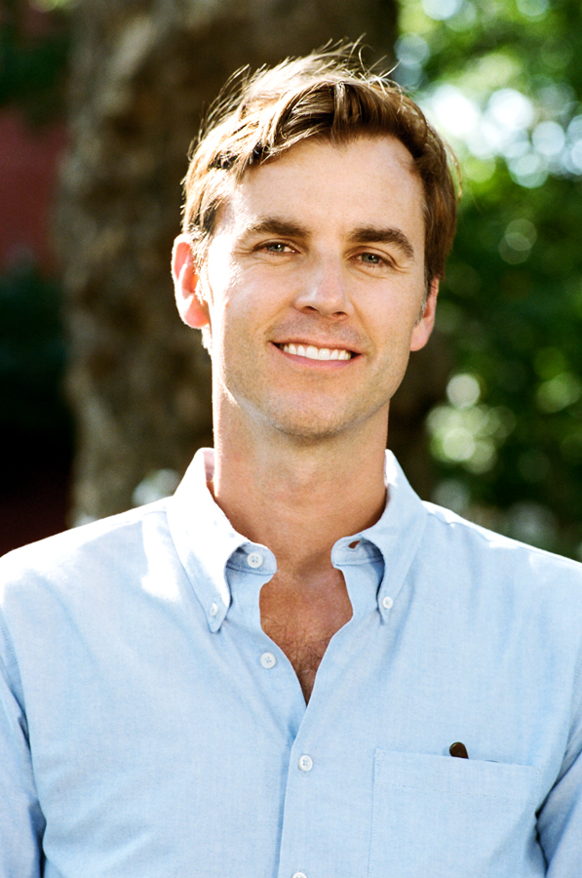

One of the first novels from Regan Arts, Judith Regan's much talked about and highly anticipated new publishing venture, will be IMMUNITY by Vogue senior editor Taylor Antrim. A fast-paced literary thriller, IMMUNITY is set in a New York City very much like our own—a jittery, paranoid place, still recovering from a global medical disaster, where the extremes between rich and poor have grown wider than ever. Catherine Duval, a fallen socialite who all-too-briefly inhabited the world of the 1%, has tumbled into desperate straits. When she receives a mysterious offer to join the staff of a luxury concierge service, she jumps at the prospect of a job with security. But soon her work catering to the outlandish whims of the city’s ultra-wealthy pulls her into a frightening conspiracy. As the hidden agendas of her employer and his shadowy clients emerge, Catherine must reckon with choices she’s made and how far her desperation will take her. A sharp-eyed exploration of class and wealth, IMMUNITY is a timely page-turner set within the sinister circles of privilege.

Early raves for IMMUNITY:

"Set in an imagined America that's appallingly indistinguishable from our own, Immunity offers a double black vodka of dystopia: very dry, very smooth, and very lethal." -Joseph O’Neill, author of Netherland and The Dog

“In this smart, scary report from the day after tomorrow, Taylor Antrim gives us a New York we recognize immediately from our anxious daydreams: the broken city after the catastrophe. A paranoid thriller for an age that’s lost its faith in conspiracies, Immunity is both a delivery system for adrenaline and a first attempt at a survival guide for the future.” -Gabriel Roth, author of The Unknowns

“I’m left haunted by how perfectly Taylor Antrim zeroes in on the zeitgeist of right now. To call Immunity a medical thriller doesn’t nearly sum up what’s contained here: all the panic, the violence, the desire we’re capable of if given the right circumstances.” -Mary Beth Keane, author of Fever and The Walking People
“A whip-smart send-up of New York City elite, set in a catastrophic future America that feels chillingly real. Devastating and darkly hilarious, this novel is essential reading for our time.” -Laura van den Berg, author of The Isle of Youth and Find Me

A senior editor at Vogue, Taylor Antrim is the author of the novel The Headmaster Ritual. His short stories have appeared in numerous publications including Five Chapters, American Short Fiction, and Best American Short Stories. He lives in Brooklyn with his wife and two children.

ABOUT REGAN ARTS:
Regan Arts is a creator and producer of content across all media platforms.
A veteran publisher, talk show host, and television producer, Regan Arts CEO Judith Regan has launched the careers of hundreds of authors and published a wide range of best-selling and award-winning books. Authors include: Wally Lamb, Jess Walter, Gregory Maguire, Walter Kirn, Douglas Coupland, Howard Stern, Neil Strauss, T.J. English, Dr. Barry Sears, Eminem, Liz Goldwyn, Motley Crüe, Barbara Bestor, Robert McKee, Ludo Lefevbre, Rachel Ashwell, General Tommy Franks, Kelly Wearstler, Michael Moore, Rush Limbaugh, Sean Hannity, Arianna Huffington, Sammy Davis Jr., Nicole Richie, Jose Conseco, and Dr. Drew Pinsky.
Regan Arts is a Phaidon Global company.

